Name: Prof. Ashwini V Sadlapurkar
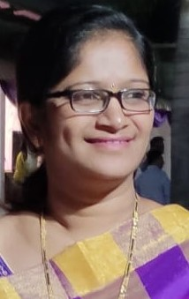Photo
Designation: Assistant Professor
Qualification: MSc, (Ph D*)
Age: 35
Experience: 12
Email Id: ashwinisadlapurkar@orchidengg.ac.in
Area of Interest: Solvent Extraction
Publications:
1. International Conference:
2. National Conference:
3. International Journal: 02
4. National Journal:
Subject Taught:
1. Engg Chemistry
2. Environment Engg.
Awards & Recognition:
Best teacher award in the year 2021
Achievements:
Conferences / STTP / Workshops
Conference-02
STTP- 10
Workshops- 05

Committee Member:
1) Hostel Rector

Professional Memberships:

